creating a device group
1. Open the Microsoft Intune portal and sign in.
2. In the Intune Management Console, click the Groups link on the left side.
3. In the window on the right, under Tasks, click the Create Group link (shown in Figure 6.7 ).
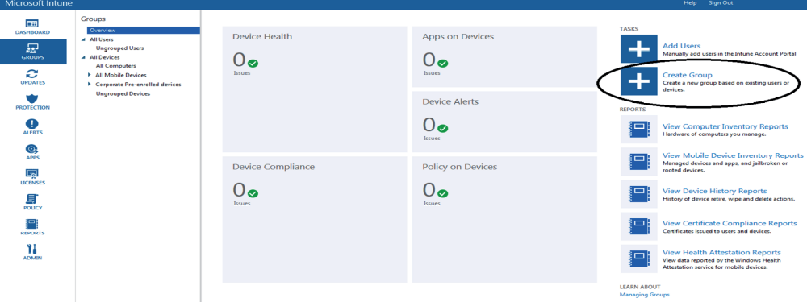
4. At the Create Group screen, under Group Name type My Devices. You can add a description to the Description section. Under the section called Select, choose a parent group, click the All Devices choice, and then click Next.
5. At the Define Membership Criteria screen, choose what type of devices you want to include. For this exercise, we are changing the device type from Mobile to All Devices. Click Next.
6. At the Define Direct Membership screen, you can include or exclude devices from this group. Since this group was created using all devices, we are not going to exclude anything. Just click Next.
7. At the Summary screen, verify that everything is correct and click the Finish button
(shown in Figure 6.8).
